AMBEKESHWAR INSTITUTE OF TECHNOLOGY & MANAGEMENT


SUMMER INTERNSHIP
PROJECT REPORT
2026-27

“Lost & Found”
A Web-Based Lost and Found Management System.

Enrollment No: E24200835500037
CSE 3rd YEAR 5th Semester

Project Type: Summer Internship Project | Domain: Mern-Stack Web Development

Submitted By: Yashvardhan Mishra Submitted To: Ms. Fiza Hussain

DECLARATION

I hereby declare that the report entitled “Lost and Found System for Users”, prepared and submitted to the Ambekeshwar Institute of Technology & Management, Lucknow, Uttar Pradesh, is a genuine record of my work completed in partial fulfilment of the requirements for the award of the Diploma in Computer Science and Engineering.
This project has been carried out under the guidance and supervision of Sambhav Jain Sir. I further declare that this report is based on my own work and that its contents have not been submitted, either wholly or partially, to any other university or institution for the award of any degree, diploma, or other academic qualification.

Place: Lucknow
Date: 03/10/2026
Student’s Name: Yashvardhan Mishra
Enrollment No.: E24200835500037
Signature of Student: __________________________

Acknowledgment

I would like to acknowledge everyone whose assistance and guidance contributed to the successful completion of this project. Their valuable contributions and encouragement made this work possible.
I am thankful to the management and faculty members of Ambekeshwar Institute of Technology & Management, Lucknow, for providing the necessary resources, facilities, and academic environment required to complete this project.
I am especially grateful to my project guide, Sambhav Jain Sir, for his expert guidance, constructive suggestions, and timely feedback throughout the project. His patience and continuous assistance helped me overcome challenges and complete the work effectively.
I also appreciate the faculty members of the Department of Computer Science and Engineering for their academic guidance and cooperation during my studies and throughout this project.
Finally, I would like to thank my family and friends for their understanding, motivation, and encouragement. Their constant presence gave me the confidence to remain focused and complete this project successfully.

Index
S.No. | Title | Page no.
1 | Declaration | 1
2 | Acknowledgement | 2
3 | Index | 3
4 | Introduction | 4
5 | Problem Definition | 5
5.1 | Purpose | 6
5.2 | Scope | 7
6 | Objective | 8
6.1 | Functional requirements | 3
6.2 | Non-Functional requirements | 3-4
7 | Requirement Specifications | 5
8.1 | Hardware requirements | 6
8.2 | Software requirements | 7
9 | Module Description | 8
10 | Problem Formulation | 9
11 | Feasibility Study | 10
12 | Problem Specifications | 11-15
13 | System Architecture Design | 16-17
14 | System Analysis | 18
15 | E-R Diagram | 19-22
16 | Data Flow Diagram | 23-26
17 | Project Planning & Scheduling | 27-28
18 | Coding | 29-50
19 | Screenshot | 51
20 | Testing | 52-59
21 | Conclusion | 60
22 | Future Scope | 61
23 | Bibliography | 62

- INTRODUCTION
The Lost and Found System is a user-centric platform designed to help individuals report and recover lost items efficiently. In public places such as schools, colleges, transport stations, malls, and parks, items are frequently misplaced or lost. Traditionally, reporting and recovering such items involves manual processes that are time-consuming and often ineffective.
This system simplifies the process by allowing users to digitally report lost items, describe them in detail, upload relevant images, and search for found items that match their descriptions. It ensures transparency, faster communication, and better chances of retrieving lost belongings.
By leveraging technology, the system bridges the gap between those who have lost items and those who have found them. It offers features like real-time notifications, item tracking, and secure user verification to prevent misuse.
Ultimately, the Lost and Found System for Users enhances public convenience, reduces the stress of losing personal belongings, and fosters a responsible and connected community.

- PROBLEM DEFINITION
In many public and private environments such as schools, universities, offices, transportation hubs, and shopping malls, individuals often misplace or lose personal items. Traditional lost and found processes are usually manual, unorganized, and inefficient. Users must rely on word-of-mouth communication, physical notice boards, or direct interaction with authorities to report or inquire about lost items.
This leads to several key problems:
- Lack of centralized information: No unified platform exists where users can easily search for or report lost and found items.
- Time-consuming process: Locating an item manually can take days or even weeks, often without success.
- Limited accessibility: Users cannot access lost and found records remotely, especially outside of working hours or physical premises.
- Poor communication: There is often no effective system to notify users when an item matching their description is found.
- Security concerns: Without verification, found items may be returned to the wrong person or mishandled.
The lack of a reliable, user-friendly, and automated solution makes it difficult to recover lost belongings and creates inconvenience for both users and administrators. Therefore, there is a strong need for a digital Lost and Found System that empowers users to efficiently report, search, and claim items through a secure and accessible platform.

Scope:

The Lost and Found System aims to provide a centralized, user-friendly, and accessible digital platform for individuals to report, search, and claim lost or found items. The system will cater to users in environments such as schools, colleges, offices, public transport stations, malls, and other institutions where item misplacement is common.

The scope includes:

User Registration and Login: Secure authentication for users to access their accounts.

Item Reporting: Users can report lost or found items with detailed descriptions, categories, date/time, and optional photos.

Search Functionality: A powerful search engine to filter items based on keywords, category, location, or date.

Matching Algorithm: System will suggest possible matches between lost and found reports to speed up item recovery.

Notifications: Automatic alerts sent to users when a potential match is identified.

Admin Panel: For system administrators to verify, monitor, and manage user reports and prevent spam or fraudulent claims.

Mobile Responsiveness: Compatible design for mobile and desktop devices to ensure ease of access anytime, anywhere.

Data Privacy and Security: Protection of user data and prevention of unauthorized access or misuse.

Out of Scope (not covered in this version):

Real-time physical tracking of items (e.g., via GPS or RFID).

Integration with law enforcement or third-party services.

Payment processing for item recovery rewards.

The project focuses on creating a reliable, efficient, and easy-to-use platform that enhances the chances of lost items being reunited with their rightful owners while ensuring security and accountability.

- OBJECTIVE
The primary objective of the Lost and Found System for Users is to streamline and digitize the process of reporting, locating, and recovering lost or found items in public and private environments.
Key Objectives:
- To provide a centralized digital platform where users can report lost or found items quickly and conveniently.
- To increase the chances of item recovery by allowing users to view and search all reported items in one place.
- To reduce the dependency on manual processes such as notice boards or verbal communication.
- To offer a secure environment where only authenticated users can report and claim items, reducing false claims.
- To enable automated matching of lost and found reports using item details like name, category, description, and location.
- To improve communication by notifying users when a similar item is reported as found or lost.
- To maintain proper records and logs for administrative and legal purposes.
- To be accessible from any device, including smartphones and desktops, allowing users to interact with the system anytime, anywhere.
Functional Requirement:
Functional requirements define what the system should do to fulfil its objectives. The Lost and Found System must provide the following core functionalities to both users and administrators:
User-Side Functional Requirements:
- User Registration and Login:
  - Users must be able to create accounts using email, phone, or social login.
  - Secure login system with username and password.
- Profile Management:
  - Users can update their personal information such as name, contact number, email, etc.
- Report Lost Item:
  - Users can submit a lost item report including item name, description, date, category, location, and photo (optional).
- Report Found Item:
  - Users can report an item they found with similar details: category, image, location, and description.
- Search and Filter Items:
  - Users can search the database for items using keywords, date, category, and location filters.
- Item Match Suggestions:
  - The system automatically suggests possible matches between lost and found items based on keywords and filters.
- Notification System:
  - Users receive email or in-app alerts if a matching item is found or reported.
- Claim Request:
  - Users can send a request to claim a found item, with an option to chat or send proof of ownership.
Admin-Side Functional Requirements:
- Admin Login:
  - Only verified admins can access the admin panel.
- User Management:
  - View, update, or block user accounts in case of suspicious activity.
- Report Moderation:
  - Review and approve/reject reported items to prevent spam or abuse.
- Database Management:
  - Maintain and back up records of all reports and claims.
- Generate Reports:
  - View analytics such as number of lost/found items, user activity, and recovery success rate.

Non-Functional Requirements:

Non-functional requirements define the quality attributes of the system. They specify how the system should perform rather than what it should do.
1. Usability:
- The system should have an intuitive and user-friendly interface accessible to both technical and non-technical users.
- Mobile and desktop responsive design for cross-device usability.
2. Reliability:
- The system should ensure high availability with minimal downtime.
- It should correctly match lost and found items without data loss or corruption.
3. Performance:
- Item search and match operations should be processed in under 2 seconds.
- The system should handle at least 100 concurrent users without performance degradation.
4. Scalability:
- The system should be scalable to accommodate an increasing number of users and item reports over time.
5. Security:
- Secure login and authentication using password encryption and session management.
- Only authorized users can report or claim items.
- Admins should have access control to sensitive actions.
6. Maintainability:
- The system should be built using modular architecture to allow easy updates, debugging, and feature enhancements.
7. Data Integrity:
- All data input (item details, user info) should be validated and stored safely to avoid inconsistencies.
8. Backup and Recovery:
- The system should support automatic database backups and easy recovery options in case of system failure.
- REQUIREMENTS SEPECIFICATIONS

HARDWARE SPECIFICATION

Component | Minimum Requirement | Recommended Requirement
Processor | Quad-Core (e.g., Intel Xeon / Ryzen) | 8-Core Server Grade CPU
RAM | 8 GB | 16–32 GB
Storage |  | 512 GB SSD or NVMe
  256 GB SSD
Network | 10 Mbps or above | 100 Mbps or above

SOFTWARE SPECIFICATION

Software | Description
OS
  Windows 10+, Linux, or macOS
Browser | Google Chrome, Firefox, Safari
Framework | React.js
Libraries | Axios, React Router, Bootstrap/Tailwind CSS

- MODULE DISCRIPTION
The Lost and Found System is divided into several interconnected modules to ensure smooth functionality, scalability, and manageability. Each module performs a specific role in helping users report, search, and claim lost or found items.
1. User Module
- Purpose: Enables users to interact with the system.
- Features:
  - User registration and login
  - Profile management
  - Report lost and found items
  - Search and filter items
  - View item details and send claim requests
  - Receive notifications about matches
2. Lost Item Module
- Purpose: Manages the process of reporting lost items.
- Features:
  - Form to submit details (item name, description, date, location, category)
  - Optional image upload
  - Stores data in the database
  - Links user ID to the report for identification

3. Found Item Module
- Purpose: Handles submissions of found items.
- Features:
  - Allows users to report found items
  - Collects information such as category, location, description, and photo
  - Makes found items searchable by others
4. Search and Matching Module
- Purpose: Helps users find their items and suggests likely matches.
- Features:
  - Keyword and filter-based item search
  - Smart match suggestions based on item attributes
  - Displays matched results for user review
5. Notification Module
- Purpose: Keeps users updated with real-time alerts.
- Features:
  - Sends alerts when a new item matches their report
  - Notifications for claim approvals or messages
  - Email/SMS or in-app notifications
6. Claim and Verification Module
- Purpose: Allows users to request claims and verify ownership.
- Features:
  - Users send claim requests with additional proof
  - Owner and finder can communicate
  - Admin may intervene for final verification
7. Admin Module
- Purpose: Provides system control and moderation capabilities.
- Features:
  - Admin login and dashboard
  - User account management
  - Approve or reject item reports
  - Generate analytics and usage reports
  - Moderate suspicious or flagged content

- PROBLEM FORMULATION
In today's busy and fast-moving environments such as educational institutions, workplaces, public transport systems, and shopping complexes, the misplacement or loss of personal items is a common occurrence. Traditional methods of managing lost and found cases—such as notice boards, manual logs, or verbal inquiries—are inefficient, time-consuming, and prone to human error.
There is currently no systematic approach that allows users to:
- Report a lost or found item easily,
- Search for matching items quickly, and
- Communicate securely with the other party involved.
This leads to problems such as:
- Low item recovery rate
- Lack of user trust and transparency
- Wastage of time and resources
- Inability to track or verify item ownership
To address these challenges, there is a clear need for a centralized, digital solution that streamlines the entire lost and found process. Such a system must be:
- User-friendly
- Easily accessible (web/mobile)
- Fast and reliable
- Capable of verifying user identity and item authenticity
Thus, the formulated problem can be stated as:
"To design and implement an intelligent, secure, and efficient Lost and Found Management System that enables users to report, search, and recover lost or found items through a centralized digital platform, improving transparency, communication, and recovery success rates."

- FEASIBILITY STUDY
A feasibility study evaluates whether developing a Lost and Found System using the MERN stack is viable from technical, economic, operational, legal, and timeline perspectives.
1. Technical Feasibility:
- The MERN stack (MongoDB, Express.js, React.js, Node.js) is a modern, powerful JavaScript-based full-stack solution.
- It supports real-time features, REST APIs, and responsive UI/UX design using React.
- MongoDB offers flexible, scalable NoSQL storage for item data and user records.
- Node.js and Express.js allow for fast, scalable server-side processing.
2. Economic Feasibility:
- MERN is open-source and free to use—no licensing fees.
- Hosting options like Render, Vercel, Netlify, or MongoDB Atlas are available at low or no cost for small projects.
- Suitable for academic, institutional, or startup-scale deployment with minimal investment.
3. Operational Feasibility:
- End users (students, staff, general public) can easily interact through a React-based UI.
- Admin dashboards can be built with reusable components for efficient item and user management.
- Real-time updates and notifications (via sockets or polling) can improve recovery success.
4. Legal Feasibility:
- Using MERN does not raise any legal issues.
- By implementing proper user authentication, privacy policies, and secure data handling (e.g., JWT for auth, HTTPS), the app can be made compliant with data protection standards.

5. Schedule Feasibility:
- A small development team (2–4 members) can complete the MVP (Minimum Viable Product) in 4–6 weeks.
- React speeds up front-end development through reusable components.
- Node.js and Express.js support rapid backend prototyping.

- PROBLEM SPECIFICATION
The Lost and Found System aims to address the inefficiencies of traditional item recovery methods in public places by creating a modern web-based platform. This system will be developed using the MERN stack (MongoDB, Express.js, React.js, Node.js) to ensure a responsive, scalable, and real-time solution.
Problem Statement:
Individuals frequently lose personal belongings in shared spaces like schools, colleges, offices, parks, and transit stations. Manual tracking through logbooks or notice boards is inefficient, delayed, and unreliable. There is a lack of a centralized, secure, and user-friendly platform to report and retrieve lost and found items.
Detailed Problem Specification:
- Lack of Centralization:
  - No unified digital database exists where all lost and found items are stored or searched.
- Manual Processes:
  - Time-consuming reporting and searching using offline tools like registers or physical notice boards.
- Limited Accessibility:
  - Users cannot report or search for items remotely or outside office hours.
- No Notification System:
  - Users don’t get updates if a similar item is found or reported.

- Verification Issues:
  - Difficulty in verifying item ownership and preventing false claims.
- No Matchmaking Mechanism:
  - Manual comparison between reported lost and found items results in missed connections.
Assumptions:
- Users will provide valid item descriptions and contact details.
- Admins will moderate reported items and claims to avoid misuse.
- The system will be deployed on a secure platform (e.g., Vercel + MongoDB Atlas).

COMPONENT DIAGRAM
Here comes your component diagram for a Lost and Found System built with the MERN stack!
The diagram illustrates how major components like the frontend (React), backend (Node.js/Express), database (MongoDB), and APIs interact to support users in reporting and finding lost items. Let me know if you'd like a breakdown of each component or help building it out!

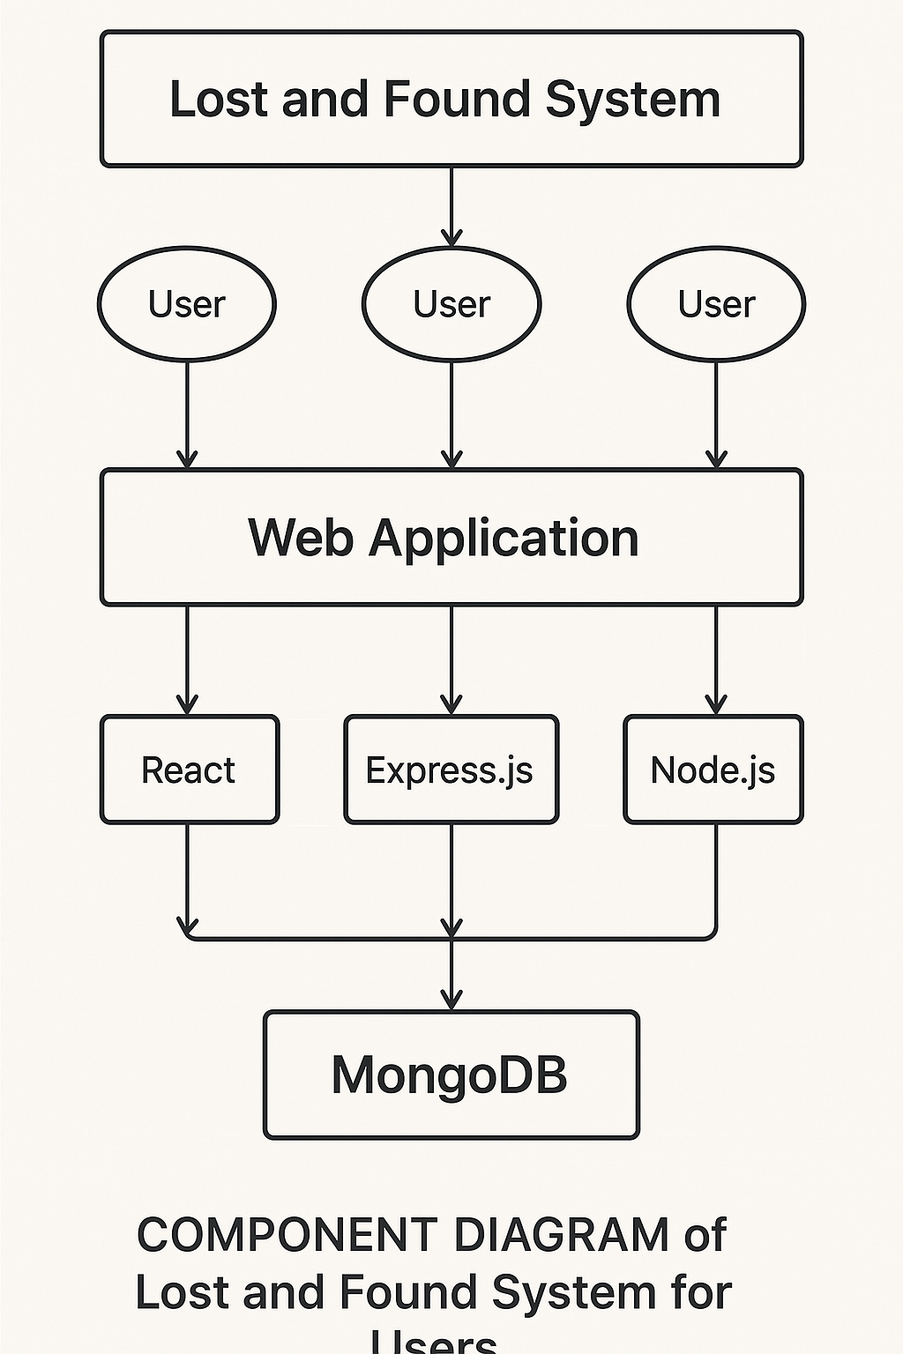

Figure of Component Diagram

Deployment Diagram:
Deployment and component diagram combine the features of both diagrams into one diagram.
The deployment diagram contains nodes and connections. A node usually represents a piece of hardware in the system. A connection depicts the communication path used by the hardware to communicate and usually indicates a method such as TCP/IP.

DB
UI
Web Server

Web pages

Figure of Deployment Diagram

- SYSTEM ARCHETECTURE DESIGN
Defining System:
Collection of components, which are interconnected, and work together to realize some objective, from a system. There are three components in every system, namely input, processing and output

Input Output
Processing

System Development of Life Cycle:
The System development life cycle (SDLC), or Software development process in systems engineering, information systems and software engineering, is a process of creating or altering information systems, and the models and methodologies that people use to develop these systems. In software engineering, the SDLC concept underpins many kinds of software methodologies. Broadly, following are the different activities to be considered while defining the system development life cycle for the said project:
- Problem
- Definition
- System Analysis
- Study of existing system
- Drawback of the existing system
- Proposed system
- System Requirement study
- Data flow analysis
- Feasibility study
- System design
- Input Design (Database & Forms) Updating
- Query /Report
- Design
- Administration
- Testing
- Implementation
- Maintenance
- SYSTEM ANALYSIS
Systems analysis is the study of sets of interacting entities, including computer systems analysis. This field is closely related to requirements analysis or operations research. It is also "an explicit formal inquiry carried out to help someone (referred to as the decision maker) identify a better course of action and make a better decision than he might otherwise have made.
System development can generally be thought of having two major components: systems analysis and systems design. In System Analysis more emphasis is given to understanding the details of an existing system or a proposed one and then deciding whether the proposed system is desirable or not and whether the existing system needs improvement.
Systems design is the process of defining the architecture, components, modules, interfaces, and data for a system to satisfy specified requirements. If the broader topic of product development "blends the perspective of marketing, design, and manufacturing into a single approach to product development," then design is the act of taking the marketing information and creating the design of the product to be manufactured. Systems design is therefore the process of defining and developing systems to satisfy specified requirements of the user. Until the 1990s systems design had a crucial and respected role in the data processing industry. In the 1990s standardization of hardware and software resulted in the ability to build modular systems. The increasing importance of software running on generic platforms has enhanced the discipline of software
- ENTITY RELATION DIAGRAMS
The Entity Relation Model or Entity Relation Diagram (ERD) is a data model or diagram for high-level description of conceptual data model, and it provides a graphical notation for representing such data models in the form of entity relationship diagrams. Such models are typically used in the first stage of Management information management system design; they are used for example, to describe information needs and/ or the type of information that is to be stored in the Database during the requirement analysis. The data modeling technique, however, can be used to describe any ontology (i.e. an overview and classification of used terms and their relationships) for a certain universe of discourse (i.e. area of interest).

ER DIAGRAMS:

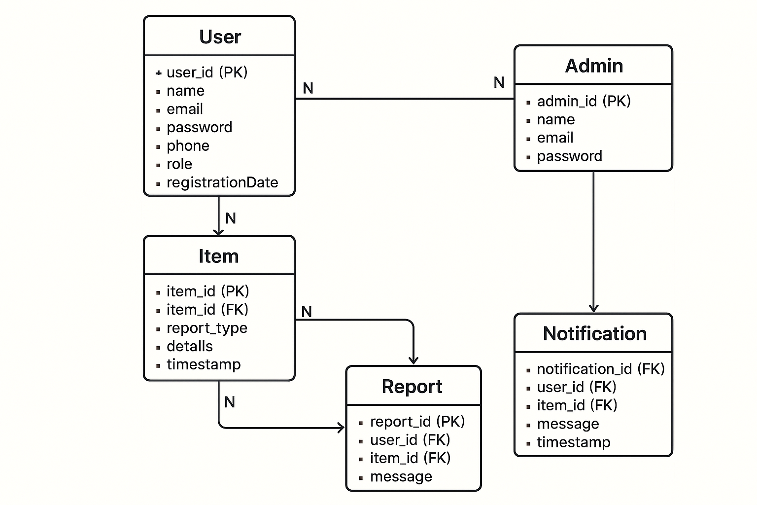
Activity Diagram:

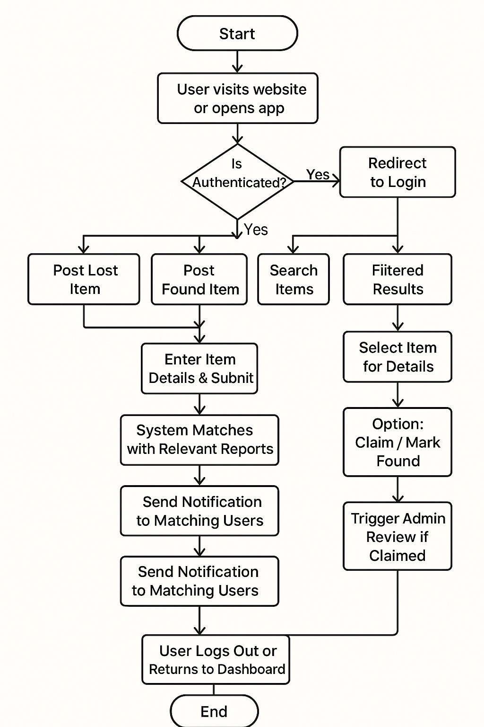

Event Diagram:

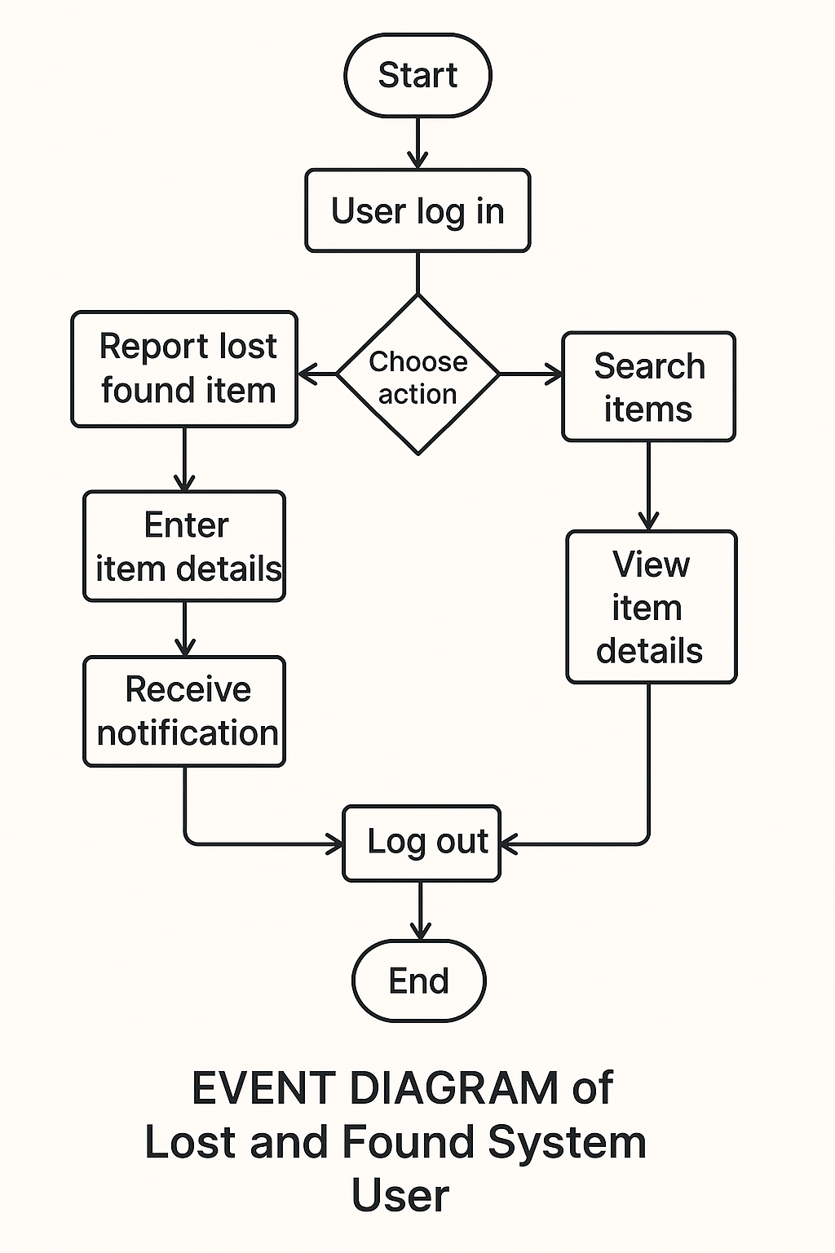

- DATA FLOW DIAGRAM
The data flow diagram shows the flow of data within any system. It is an important tool for designing phase of software engineering. Larry Constantine first developed it. It represents graphical view of flow of data. It’s also known as BUBBLE CHART. The purpose of DFD is major transformation that will become in system design symbols used in DFD.
In the DFD, four symbols are used and they are as follows.
- A square defines a source (originator) or destination of system data.

- An arrow identifies data flow-data in motion. It is 2a pipeline through which information flows.

- An open rectangle is a data store-data at rest, or a temporary Repository of data.

- A circle or a “bubble “(Some people use an oval bubble) represents a process that transfers informing data flows into outgoing data flows.

Context Level Data Flow Diagram:
This level shows the overall context of the system and its operating environment and shows the whole system as just one process. Online book store is shown as one process in the context diagram; which is also known as zero level DFD, shown below. The context diagram plays important role in understanding the system and determining the boundaries. The main process can be broken into sub-processes and system can be studied with more detail; this is where 1st level

DFD comes into play.

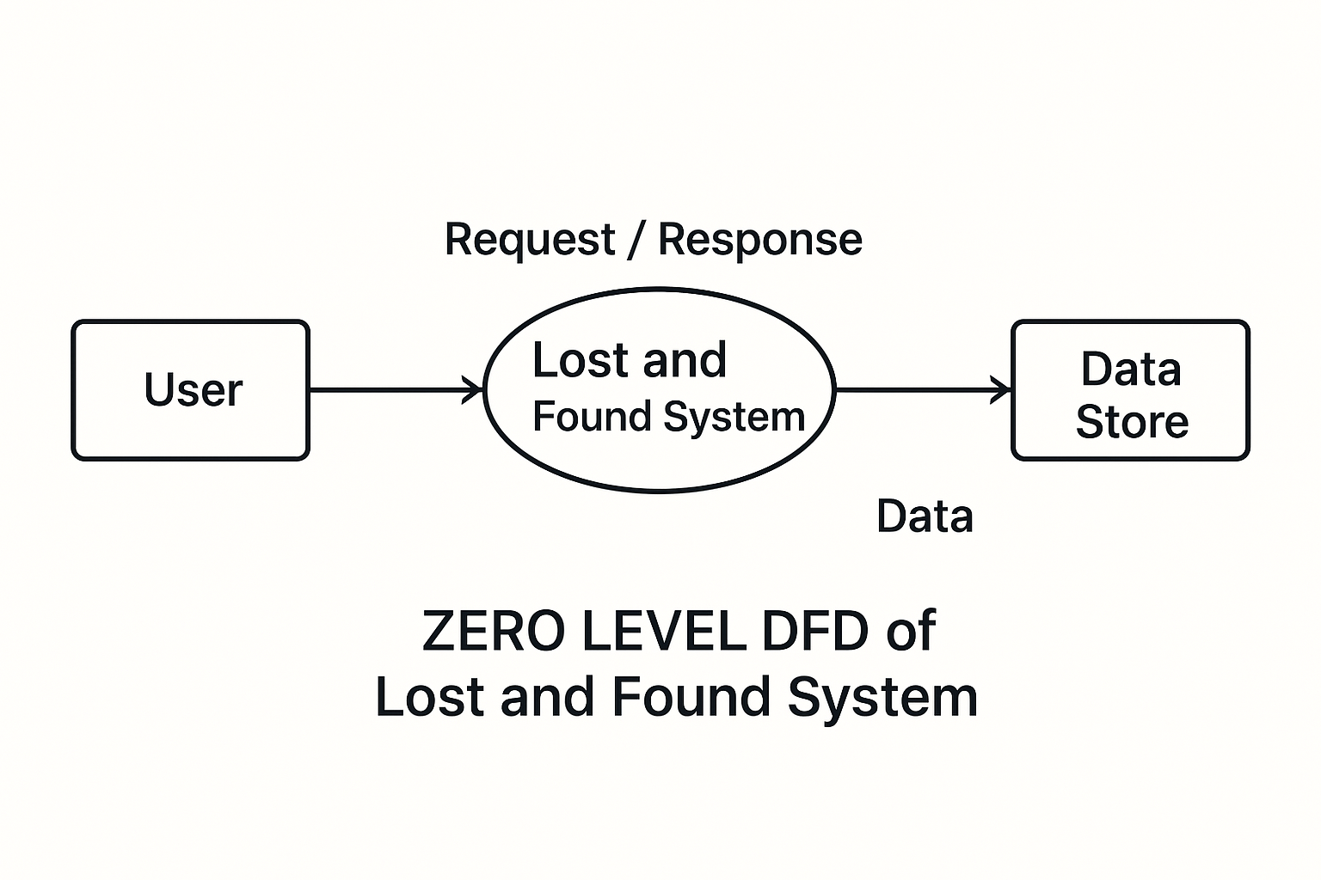

Zero Level Data Flow Diagram
First Level DFD:
This level (level 1) shows all processes at the first level of numbering, data stores, external entities and the data flows between them. The purpose of this level is to show the major high- level processes of the system and their interrelation. A process model will have one, and only one, level-1 diagram. A level-1 diagram must be balanced with its parent context level diagram,
i.e. there must be the same external entities and the same data flows, these can be broken down to more detail in level 1.
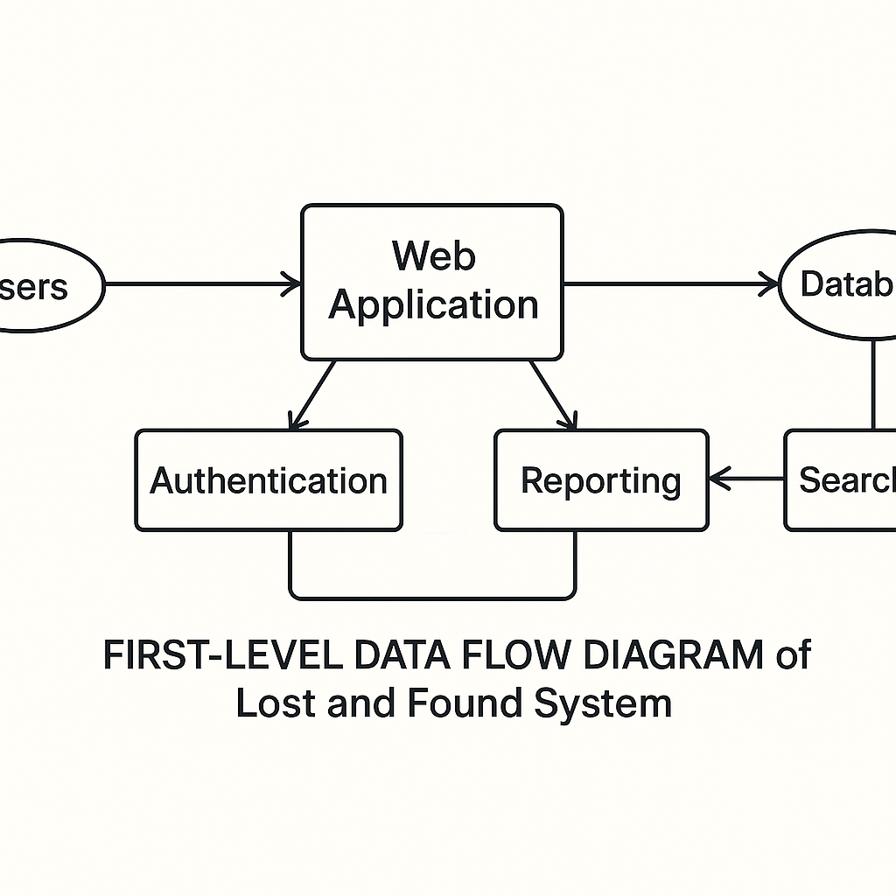

First Level Data Flow Diagram

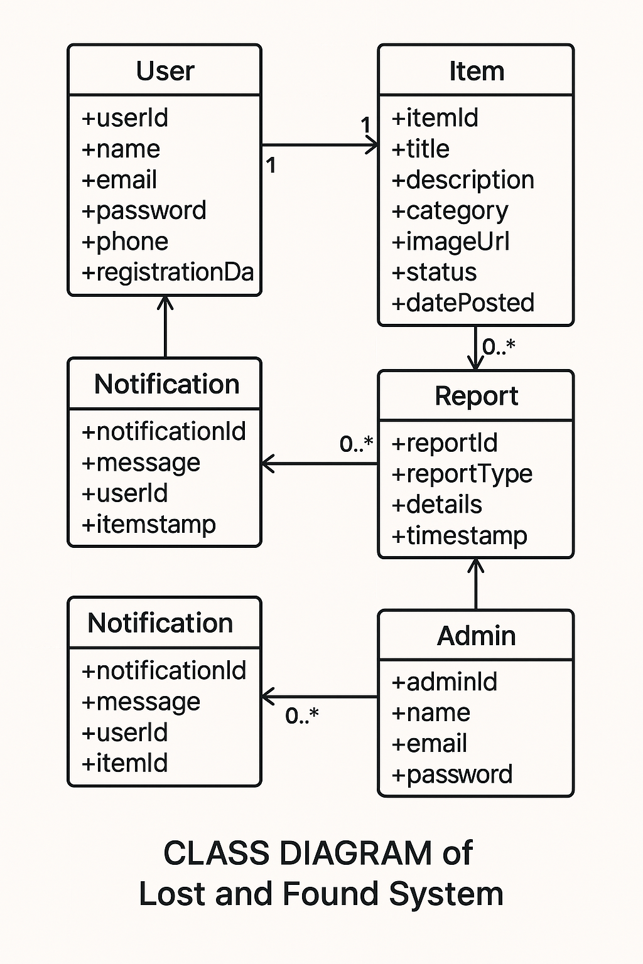
Class Diagram
- PROJECT PLANNING & SCHEDULING

Pert Chart:
A project plan needs to be created to ensure the timely completion of the project. As part of project analysis, we break the project down to a number of stages and use a Gantt chart and PERT chart to describe specific tasks and status.
The Work Breakdown Structure of our proposed system “E-Commerce” is shown below:

ID | Task Name | Duration | Start | Finish
1 | Project Initiation | 03 days | Tue  18/02/2025 | Fri  21/02/2025
2 | Draft Project Plan | 02 days | Sat  22/02/2025 | Mon  24/02/2025
3 | Analysis Phase | 09 days | Wed  26/02/2025 | Fri  07/03/2025
4 | Plan User Interviews | 02 days | Sat  08/03/2025 | Mon  10/03/2025
5 | Schedule users Interviews | 04 days | Tue  11/03/2025 | Sat  15/03/2025
6 | Conducting users Interviews | 03 days | Mon  17/03/2025 | Thu  20/03/2025
7 | System Design | 10 days | Fri  21/03/2025 | Mon  31/03/2025
8 | Modules Design | 09 days | Tue  01/04/2025 | Thu  10/04/2025
9 | Data Structure Design | 03 days | Fri  11/04/2025 | Mon  14/04/2025
10 | User Interface Design | 02 days | Tue  15/04/2025 | Thu  17/04/2025
11 | Coding Phase | 07 days | Fri  18/04/2025 | Fri  25/04/2025
12 | Testing Phase | 05 days | Fri  25/04/2025 | Wed  30/04/2025
13 | Integration Testing | 03 days | Wed  30/04/2025 | Fri  02/05/2025
14 | System Level Testing | 03 days | Fri  02/05/2025 | Mon  05/05/2025
15 | Implementation | 02 days | Tue  06/05/2025 | Wed  07/05/2025
16 | Post-Implementation Review | 04 days | Thu  08/05/2025 | Mon  12/05/2025

- CODING OF PROJECT
App.jsx
import { Route, Routes } from "react-router-dom"
import Home from "./pages/Home"
import Electronic from "./pages/Electronic"
import Others from "./pages/Others"
import Register from "./pages/Register"
import Login from "./pages/Login"
import PostDetailsElectronic from "./pages/PostDetailsElectronic"
import CreatePost from "./pages/CreatePost"
import EditPost from "./pages/EditPost"
import Profile from "./pages/Profile"
import MyPosts from "./pages/MyPosts"
import { UserContextProvider } from "./context/UserContext"

const App = () => {
return (
<UserContextProvider>
<Routes>
<Route exact path ="/electronic" element={<Electronic/>}/>
<Route exact path ="/others" element={<Others/>}/>
<Route exact path="/" element={<Home/>}/>
<Route exact path="/login" element={<Login/>}/>
<Route exact path="/register" element={<Register/>}/>
<Route exact path="/write" element={<CreatePost/>}/>
<Route exact path="/edit/:id" element={<EditPost/>}/>
<Route exact path="/myposts/:id" element={<MyPosts/>}/>
<Route exact path="/posts/post/:id" element={<PostDetailsElectronic/>}/>
<Route exact path="/profile/:id" element={<Profile/>}/>
</Routes>
</UserContextProvider>
)
}

export default App

backend/Index.js
const express = require('express')
const app = express()
const mongoose = require('mongoose')
const dotenv = require('dotenv')
const cors = require('cors')
const multer=require('multer')
const path=require("path")
const cookieParser = require('cookie-parser')
const authRoute = require('./routes/auth')
const userRoute = require('./routes/users')
const postRoute = require('./routes/posts')
const commentRoute = require('./routes/comments')

//database
const connectDB = async()=>{
try{
await mongoose.connect(process.env.MONGO_URL)
console.log("database is connected successfully")
}
catch(err){
console.log(err)
}
}

//middlewares
dotenv.config()
app.use(express.json())
app.use("/images",express.static(path.join(__dirname,"/images")))
app.use(cors({origin:"http://localhost:5173",credentials:true}))
app.use(cookieParser())
app.use("/api/auth",authRoute)
app.use("/api/users",userRoute)
app.use("/api/posts",postRoute)
app.use("/api/comments",commentRoute)

//Image Upload
const storage=multer.diskStorage({
destination:(req,file,fn)=>{
fn(null,"images")
},
filename:(req,file,fn)=>{
fn(null,req.body.img)
// fn(null,"image1.jpg")
}
})

const upload=multer({storage:storage})
app.post("/api/upload",upload.single("file"),(req,res)=>{
//console.log(req.body)
res.status(200).json("Image has been uploaded successfully!")
})

app.listen(process.env.PORT,() => {
connectDB()
console.log("app is running on port "+process.env.PORT)

})

Routes/users.js
const express=require('express')
const router=express.Router()
const User = require('../models/User')
const bcrypt = require('bcrypt')
const Post = require('../models/Post')
const Comment = require('../models/Comment')
const verifyToken = require('../verifyToken')

//Update
router.put("/:id",verifyToken,async(req,res)=>{
try {
if(req.body.password){
const salt= await bcrypt.genSalt(10)
req.body.password = await bcrypt.hashSync(req.body.password, salt)
}
const UpdatedUser=await User.findByIdAndUpdate(req.params.id,{$set:req.body},{new:true})
res.status(200).json(UpdatedUser)}

catch (err) {
res.status(500).json(err)
}
})

//DELETE
router.delete("/:id",verifyToken,async(req,res)=>{
try {
await User.findByIdAndDelete(req.params.id)
await Post.deleteMany({userId:req.params.id})
await Comment.deleteMany({userId:req.params.id})
res.status(200).json("User has been deleted ")
}
catch (err) {
res.status(500).json(err)
}
})

//GET USER
router.get("/:id",async(req,res)=>{
try {
const user =await User.findById(req.params.id)
const {password,...info}=user._doc
res.status(200).json(info)
}
catch (err) {
res.status(500).json(err)
}
})
module.exports=router

routes/posts.js
const express=require('express')
const router=express.Router()
const User = require('../models/User')
const bcrypt = require('bcrypt')
const Post = require('../models/Post')
const Comment = require('../models/Comment')
const verifyToken = require('../verifyToken')

//CREATE
router.post("/create",verifyToken,async(req,res) => {
try{
const newPost = new Post(req.body)
const savedPost = await newPost.save()
res.status(200).json(savedPost)
}
catch(err) {
res.status(500).json(err)
}
})

//UPDATE
router.put("/:id",verifyToken,async(req,res)=>{
try {
const UpdatedUser=await Post.findByIdAndUpdate(req.params.id,{$set:req.body},{new:true})
res.status(200).json(UpdatedUser)}

catch (err) {
res.status(500).json(err)
}
})

//DELETE
router.delete("/:id",verifyToken,async(req,res)=>{
try {
await Post.findByIdAndDelete(req.params.id)
await Comment.deleteMany({postId:req.params.id})

res.status(200).json("Post has been deleted ")
}
catch (err) {
res.status(500).json(err)
}
})

//GET POST DETAILS
router.get("/:id",async(req,res)=>{
try {
const post =await Post.findById(req.params.id)
res.status(200).json(post)
}
catch (err) {
res.status(500).json(err)
}
})

//GET POSTS
router.get("/",async(req,res)=>{
const query = req.query
console.log(query)
try {
const searchFilter={
title:{$regex:query.search,$options:"i"}
}
const posts =await Post.find(query.search?searchFilter:null)
res.status(200).json(posts)
}
catch (err) {
res.status(500).json(err)
}
})

//GET USER POSTS
router.get("/user/:userId",async(req,res)=>{
try {
const posts =await Post.find({userId:req.params.userId})
res.status(200).json(posts)
}
catch (err) {
res.status(500).json(err)
}
})

module.exports=router

routes/comments.js
const express=require('express')
const router=express.Router()
const User = require('../models/User')
const bcrypt = require('bcrypt')
const Post = require('../models/Post')
const Comment = require('../models/Comment')
const verifyToken = require('../verifyToken')

//CREATE
router.post("/create",verifyToken,async(req,res) => {
try{
const newComment = new Comment(req.body)
const savedComment = await newComment.save()
res.status(200).json(savedComment)
}
catch(err) {
res.status(500).json(err)
}
})

//UPDATE
router.put("/:id",verifyToken,async(req,res)=>{
try {
const UpdatedComment=await Comment.findByIdAndUpdate(req.params.id,{$set:req.body},{new:true})
res.status(200).json(UpdatedComment)}

catch (err) {
res.status(500).json(err)
}
})

//DELETE
router.delete("/:id",verifyToken,async(req,res)=>{
try {
await Comment.findByIdAndDelete(req.params.id)

res.status(200).json("Comment has been deleted ")
}
catch (err) {
res.status(500).json(err)
}
})

//GET POST COMMENTS
router.get("/post/:postId",async(req,res)=>{
try {
const Comments =await Comment.find({postId:req.params.postId})
res.status(200).json(Comments)
}
catch (err) {
res.status(500).json(err)
}
})

module.exports=router

Models/user.js
const mongoose = require('mongoose')

const UserSchema = new mongoose.Schema({
username :{
type:String,
required:true,
unique:true
},
email:{
type:String,
required:true,
unique:true
},
role: {
type: String,
enum: ['user', 'admin'], // Or add more roles if needed
default: 'user'
},
password:{
type:String,
required:true,
}
},
{timestamps:true})

module.exports = mongoose.model("User",UserSchema)
Models/post.js
const mongoose = require('mongoose')

const PostSchema = new mongoose.Schema({
title :{
type:String,
required:true,
unique:true
},
desc:{
type:String,
required:true,
unique:true
},
photo:{
type:String,
required:false,
},
username:{
type:String,
required:true,
},
userId:{
type:String,
required:true,
},
categories:{
type:Array,
},
contactNo:{
type:String,
required:true
},
type:String
},
{timestamps:true})

module.exports = mongoose.model("Post",PostSchema)

Models/comment.js
const mongoose = require('mongoose')

const PostSchema = new mongoose.Schema({
title :{
type:String,
required:true,
unique:true
},
desc:{
type:String,
required:true,
unique:true
},
photo:{
type:String,
required:false,
},
username:{
type:String,
required:true,
},
userId:{
type:String,
required:true,
},
categories:{
type:Array,
},
contactNo:{
type:String,
required:true
},
type:String
},
{timestamps:true})

module.exports = mongoose.model("Post",PostSchema)

DATABASE TABLES

User
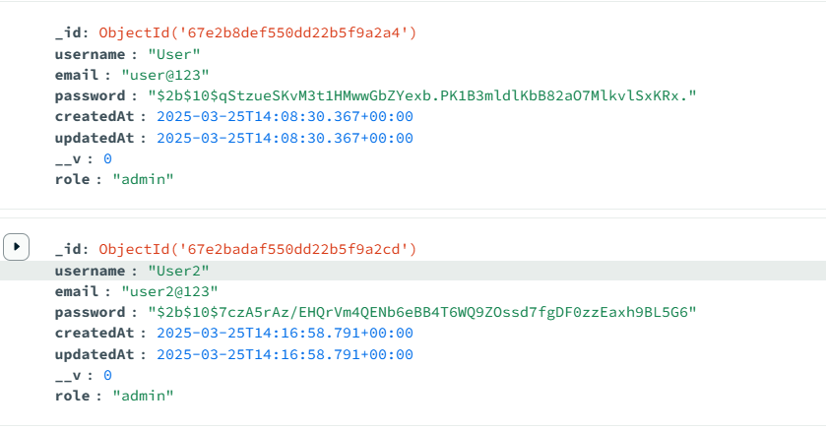

Posts
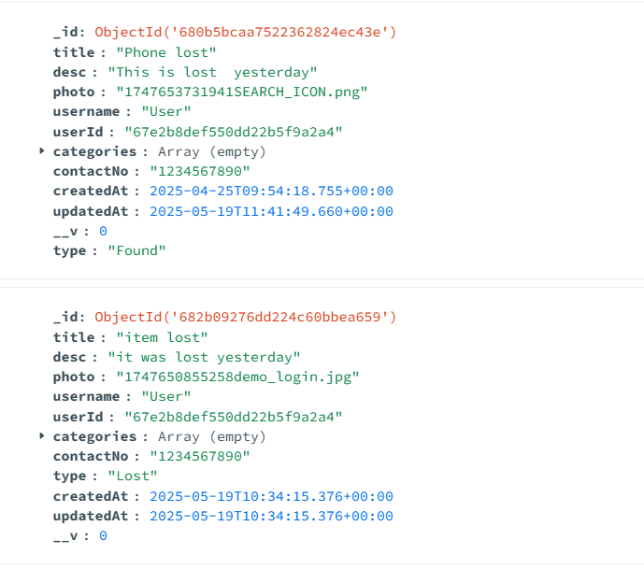

Comments
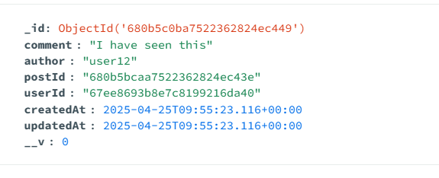

- PROJECT SCREENSHOT
Home Page
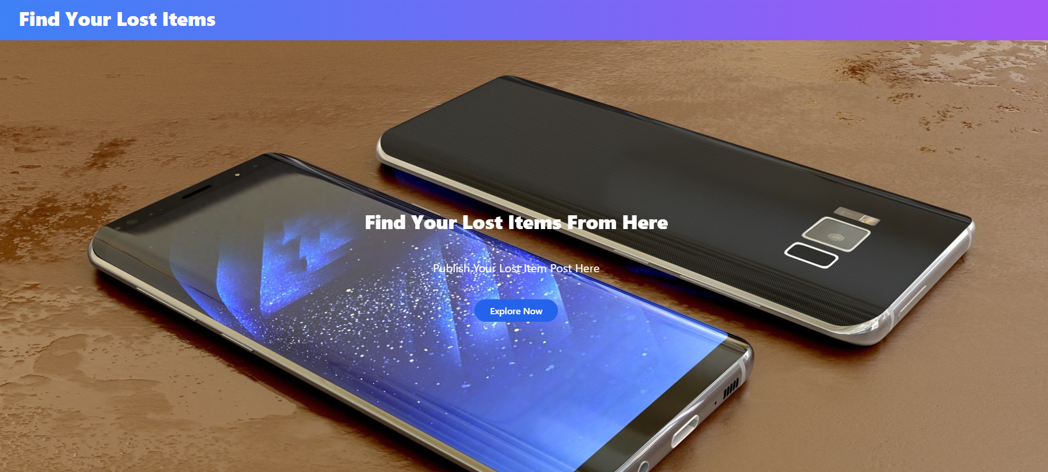

Products Page
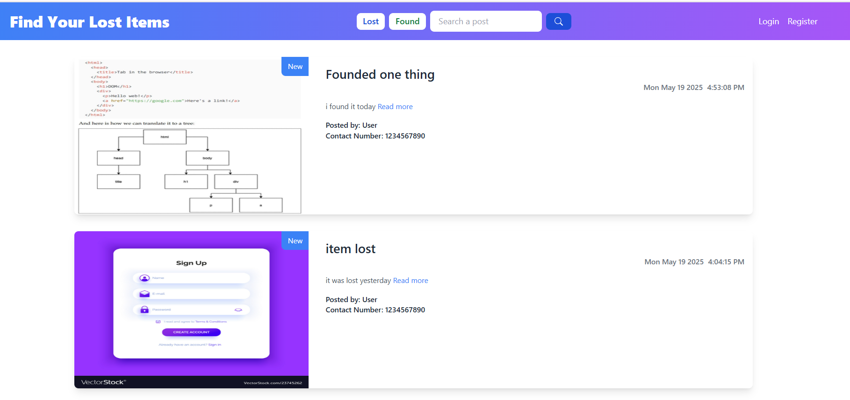
Login Page
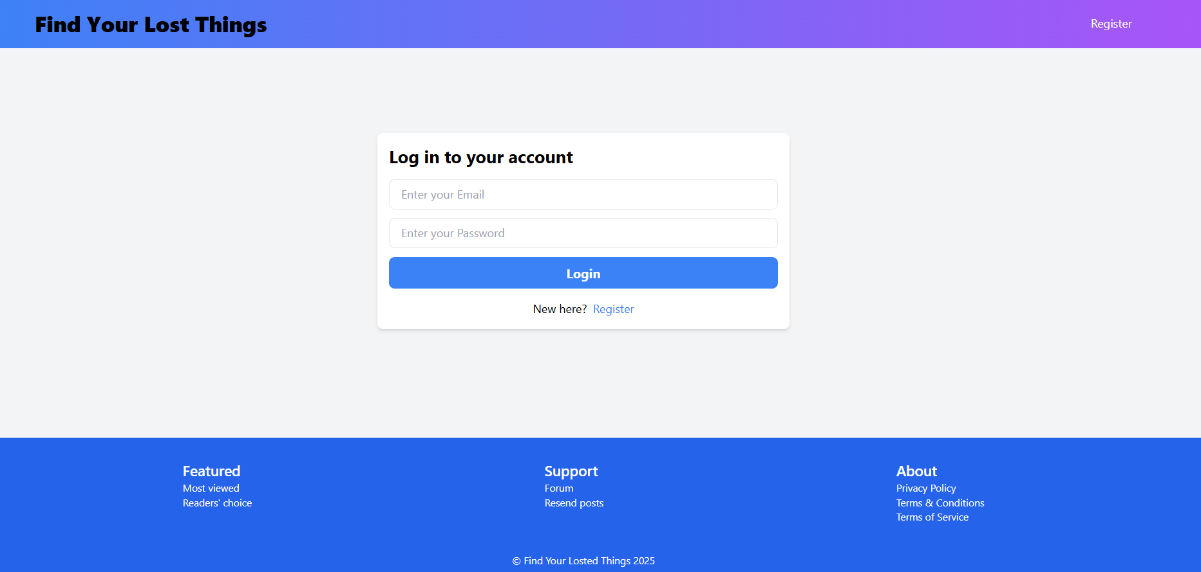

Register Page
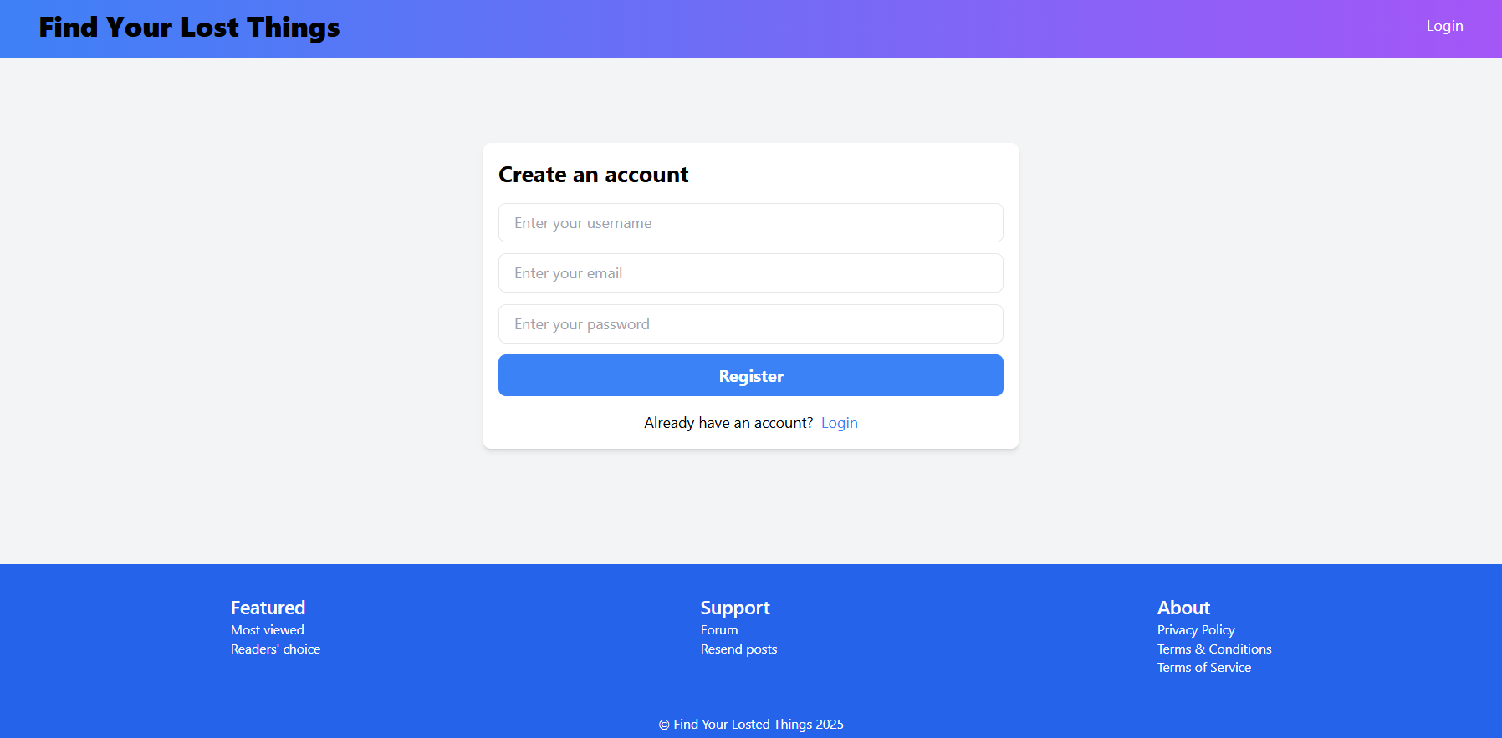

Write Page
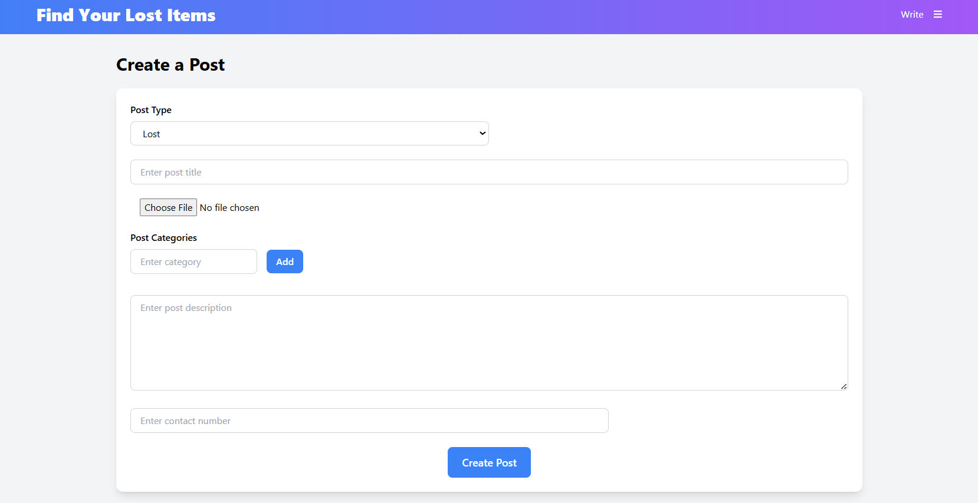

- TESTING
Testing ensures that each part of the Lost and Found System functions correctly, securely, and reliably. The system is tested using various methods to identify and resolve bugs, validate logic, and ensure smooth user interaction.
Types of Testing Used:
1. Unit Testing
- Purpose: To test individual components (functions, modules).
- Tools: Jest (for React/Node), Mocha, Chai.
- Examples:
  - Testing item submission logic
  - Testing JWT token generation and validation
  - Testing MongoDB data insertions and queries
2. Integration Testing
- Purpose: To test the flow between multiple components.
- Tools: Supertest (for APIs), Postman (manual)
- Examples:
  - Submit lost item → store in MongoDB → fetch and display in React
  - User login → protected route access

3. Functional Testing
- Purpose: To ensure the system meets user requirements.
- Scenarios:
  - Register/login successfully
  - Report lost and found items with all fields
  - Search for items by keyword and filters
  - Send and receive claim requests
  - Admin approval and rejection functions
4. UI/UX Testing
- Purpose: To ensure frontend components are working and responsive.
- Tools: Chrome DevTools, Lighthouse
- Checklist:
  - Responsive layout on desktop/mobile
  - Form validation errors and success messages
  - Button clicks trigger correct backend actions
5. Security Testing
- Purpose: To verify protection of user data and access control.
- Tests:
  - Check for SQL/NoSQL injections (MongoDB sanitization)
  - JWT token expiration handling
  - Password hashing with bcrypt
  - Preventing unauthorized access to admin routes
6. User Acceptance Testing (UAT)
- Purpose: Final validation by end-users.
- Process:
  - Provide prototype to real users (students/admins)
  - Collect feedback on usability, accuracy, speed
  - Apply changes if any bugs/issues are found

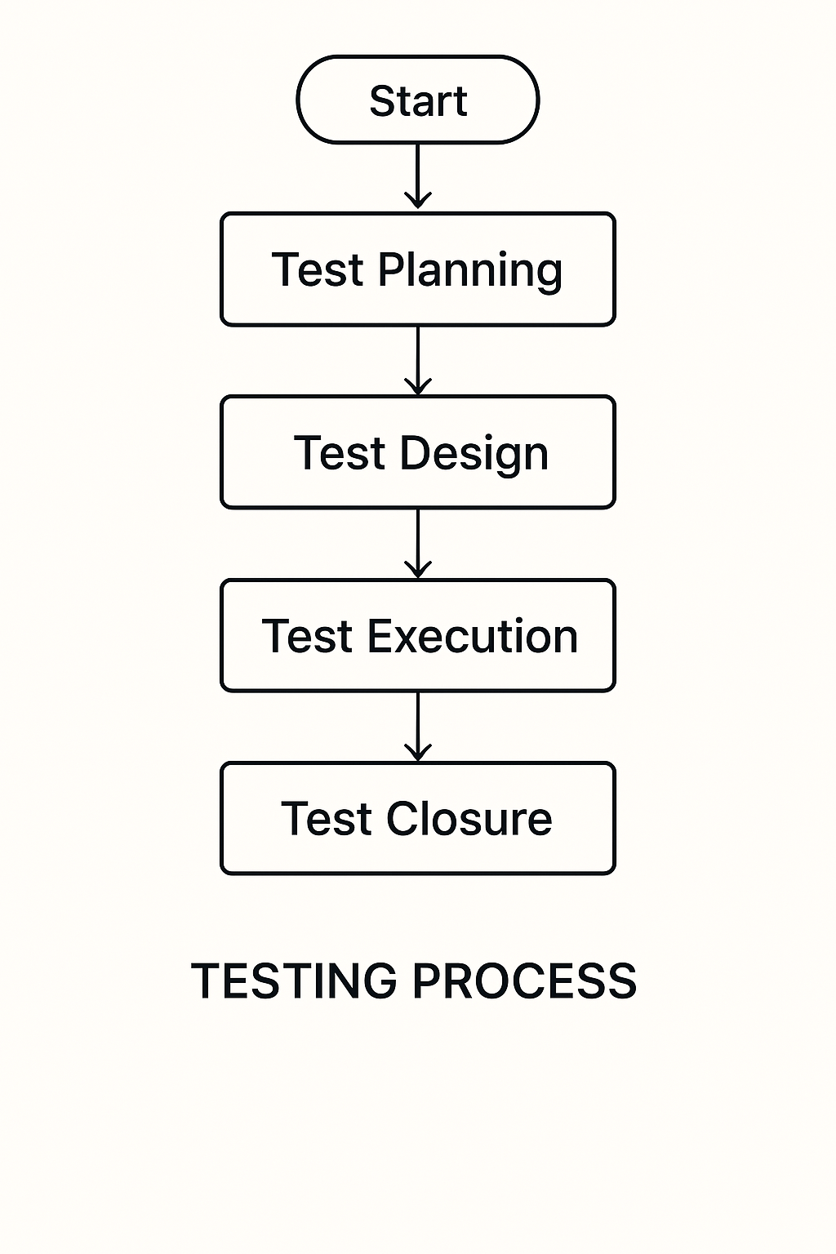
Test Plan:

The Testing Process: Developer tests the software process activity such as design, implementation and the requirement engineering. Because, design errors are very costly to repair when the system has been started to operate. Therefore, it is quite obvious to repair them at early stage of the system. So, analysis is the most important process of any project.

Requirements Tractability: As most interested portion is whether the system is meeting its requirements or not, for that testing should be planned so that all requirements are individually tested. Developer checked the output of certain combinations of input, which gives desirable results, or not. Strictly stick to our requirements specifications, give you the path to get desirable results from the system.
Tested Items
Our tested items are like:
- Data fetching from the database
- Data insertion, updating and deleting in the database
- Form access to login

Testing Schedule:
Developer has tested each procedure back to back so that errors and omissions can be found as earliest as possible. Once the system has been developed by fully developer tested it on other machines, which differs in configuration.
Testing Methods:
Software testing involves executing an implementation of the software which tests data and examining the outputs of the software and its operational behavior to check that it is performing as required.
Statistical Testing:
Statistical testing is used to test the program’s performance and reliability and to check how it works under operational conditions. Tests are designed to reflect the actual user inputs and their frequency. The stages involved in the static analysis for this system are follows:

Control Flow Analysis:
- Unreachable code
- Unconditional branches into loops
Data Use analysis:
- Variable used before initialization
- Variables declared but never used
- Variables assigned twice but never used between assignments
- Possible array bound violations
- Declared variables

Interface Analysis:
- Parameter type mismatches
- Parameter number mismatches
- Non-usage of the results of function
- Uncalled functions and procedures
Storage Management Faults:
- Data not stored in proper tables
- Data cannot be fetched from proper table
Defect Testing:
Defect testing is intended to find inconsistencies between a program and its specifications. These inconsistencies are usually due to the program faults or defects.
Unit Testing:
The Developer carries out unit testing to check if the particular module or unit of code is working fine. The unit testing comes at the very basic level as it is carried out as and when the unit of the code is developed, or a particular functionality is built. In this application we test one most important module as task allocation which is as follows:
Loop Testing:
The Tester has tested some conditions in a code of application. So, they test the looping in source code of application for finding miss route or any error or wrong direction of flow in code.
Black-Box Testing:
In black box testing or functional testing, the developer is concerned about the output of the module and software, i.e. whether the software gives proper output as per the requirements or not. In another words, this testing aims to test a program behavior against specification without making any reference to the internal structure of the program or the algorithms used.
This can be done in the following way:
- Input Interface
- Processing
- Output Interface
The tested program gets certain inputs. Then the program does its job and generates a certain output, which is collected by a second interface. This result is then compared to the excepted output, which was determined before the test.
Whitebox Testing:
It is also called ‘GLASS BOX’ or ‘STRUCTURAL’ testing. Tester has access to system design.
- Simple Loops
- Nested Loops
- Concatenated Loops
- Unstructured Loops
- Continuous Loops
They can:
- Examine the design document
- View source code
- Individual paths examine
- Logical paths examine one time
- Logical decision on their true and false.
The intention in white-box testing is to ensure that all possible feasible flow of control path through a sub- program is traversed while the software is under tested. This is not the same as saying that all statements in the sub-program will be executed as it is possible for all statements to be executed but for not all of the possible paths to be traversed. However, the converse is true; whether all the possible paths through a sub- program are traversed then all statements in sub-programs will necessarily be executed.
When considering the number of possible paths through a sub-program, two other factors need to be remembered. The first is that some of the possible paths through a sub-program turn out upon investigation to be non- feasible paths. The second consideration is that the number of possible paths to a sub-program indicated by a flow-graph analysis will indicate the minimum number of paths to ensure complete coverage. This may be less than the total number of paths which are possible when combinations of paths are allowed. White-box testing is used as an important primary testing approach. Here, code is inspected to see what it does. Tests are designed to exercise the code. Code is tested using code scripts driver etc. which are employe to directly interfaced with and drive the code. The tester can analyze the code and use the knowledge about the structure of a component to derive the test data.
Advantages of White box testing:
- As the knowledge of internal coding structure is prerequisite, it becomes very easy to find out which type of input / data can help in testing the application effectively.
- The other advantage of white box testing is that it helps with optimizing the code.
- It helps in removing the extra lines of code, which can bring in hidden defects.
Structure Testing:
Developer has done his path testing to exercise every independent execution path through a component or program. If every independent path is executed, then all statements in the components must have been executed at least once. The structure of our program is also checked.
Integration Testing:
After our individual modules the Developer tested out Developer go to the integrated to create a complete system. This integration process involves building the system for problems that arise from component interactions. Developer has applied a top-down strategy to validate high-level components of a system before design and implementations have been completed. Because our development process started with high-level components and Developer worked down the component hierarchy.
Performance Testing:
Performance testing is designed to test the runtime performance of the system within the context of the system. These tests Developer performed as module level as developer as system level. Individual modules developers tested for required performance.
Condition Testing:
Condition testing is a test case design method that exercises the logical conditions contained in a program module. If the condition is incorrect, then as least one part of the condition is incorrect. It may include:
- Boolean variable error
- String index out of Bound error
- Null pointer Assignment
- Input Output Connection Exceptions
- Arithmetic expression error
- Parsing (conversion) errors
- Image unloaded errors
Interface Testing:
Interface testing is an integral part of integration testing. Therefore, the developer checked for the following.
- Interface misuse
- Interface misunderstanding
Developer examined the code to be tested and explicitly list each call to an external component. In the system, standards tests for various modules have been performed, which are follows.
Object Testing:
Object testing is to test objects as individual components, which are often larger than single function. Here the following activities have taken place.
- Testing the individual operations associated with object.
- Testing individual object classes.
- Testing cluster of objects.
- Testing object-oriented systems.

Now we will discuss how testing and debugging is done of this application. Our application can be divided into parts like:
- To make queries to database and retrieve information from it.
- Reduce some memory requirements for the database.
- Maintain database so that unauthorized access can not affect.
Limitations
- It can run only on windows servers. It is not compatible with LINUX servers.
- It is not cent percent safe from professional hackers.
- Only registered user can buy and sell their items using this website.
- CONCLUSION
The User Module of the Lost and Found System plays a vital role in bridging the gap between users who have lost items and those who have found them. It provides a clean, intuitive interface that allows users to register, report, search, and claim items easily. With secure authentication, responsive design, and real-time notifications, the module ensures a user-centric experience that is accessible anytime, from any device.
Through this module, users can:
- Report lost or found items quickly.
- Search and filter items based on various parameters.
- Receive match notifications to increase the chances of item recovery.
- Send claim requests with proper proof and communication.
Overall, the User Module successfully enhances efficiency, reduces manual work, and increases the transparency and reliability of the lost and found process

- FUTURE SCOPE OF THE PROJECT

The User Module can be improved and extended in future iterations through the following enhancements:
- Mobile App Integration
– Develop a dedicated mobile app using React Native or Flutter for on-the-go access.
- Image Recognition for Matching
– Use AI/ML to match lost and found items using uploaded images.
- Voice Input Support
– Allow users to report or search items using voice commands for better accessibility.
- User Chat System
– Integrate a real-time chat feature between finder and claimant for smoother communication.
- User Ratings & Feedback
– Add user rating and feedback systems to improve trust in item recovery transactions.
- Multilingual Interface
– Provide support for regional languages to make the system more inclusive.
- Geo-Tagging of Reports
– Automatically capture location data when submitting reports for more accurate filtering.

